Installation Instructions – Review Center Tracker Report

* Go to Admin > Reports
* Click Add Report
* Fill in the Add/Edit Report according to the following:

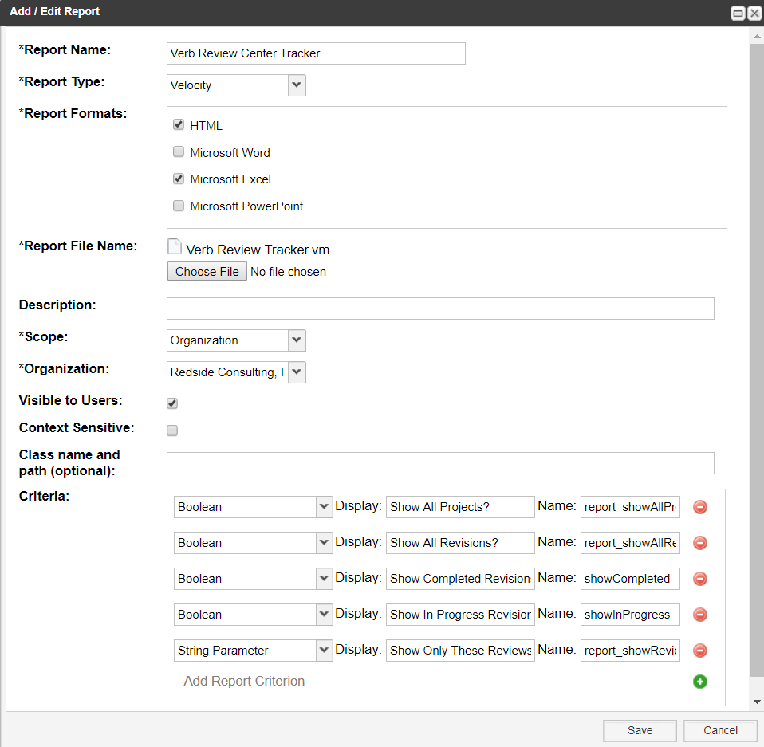

Note: Your Organization field will have a different value.

* Click Save
* Go back to Projects and click on the Reports link
* Run the report

The criteria are as follows:

|  |  |
| --- | --- |
| Show All Projects? | report_showAllProjects |
| Show All Revisions? | report_showAllRevs |
| Show Completed Revisions? | showCompleted |
| Show In Progress Revisions? | showInProgress |
| Show Only These Reviews (comma with no spaces): | report_showReviews |